**Lab19 – Understanding Queue Storage – Azure**

**Queue storage**

Azure Queue storage is a service for storing large numbers of messages that can be accessed from anywhere in the world via authenticated calls using HTTP or HTTPS. A single queue message can be up to 64 KB in size, and a queue can contain millions of messages, up to the total capacity limit of a storage account.

Common uses of Queue storage include:

* Creating a backlog of work to process asynchronously
* Passing messages from an Azure web role to an Azure worker role

**Queue Service Concepts**

The Queue service contains the following components:

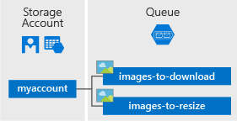

* **URL format:** Queues are addressable using the following URL format:  
  http://<storage account>.queue.core.windows.net/<queue>

The following URL addresses a queue in the diagram:

http://myaccount.queue.core.windows.net/images-to-download

* **Storage Account:** All access to Azure Storage is done through a storage account. See [Azure Storage Scalability and Performance Targets](https://docs.microsoft.com/en-us/azure/storage/common/storage-scalability-targets) for details about storage account capacity.
* **Queue:** A queue contains a set of messages. All messages must be in a queue. Note that the queue name must be all lowercase. For information on naming queues, see [Naming Queues and Metadata](https://msdn.microsoft.com/library/azure/dd179349.aspx).
* **Message:** A message, in any format, of up to 64 KB. The maximum time that a message can remain in the queue is 7 days.

**Topology:**

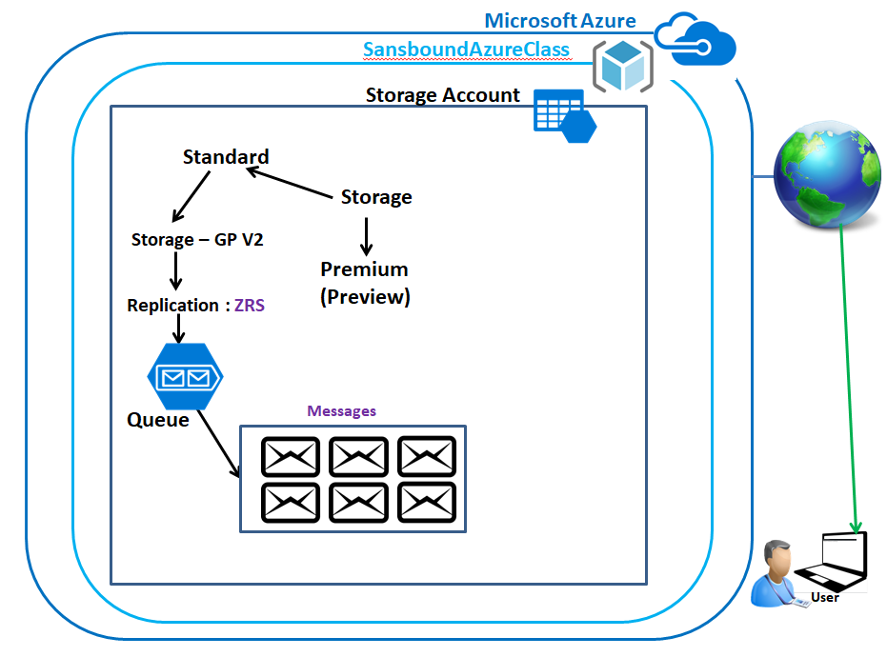

**Back-End Topology:**

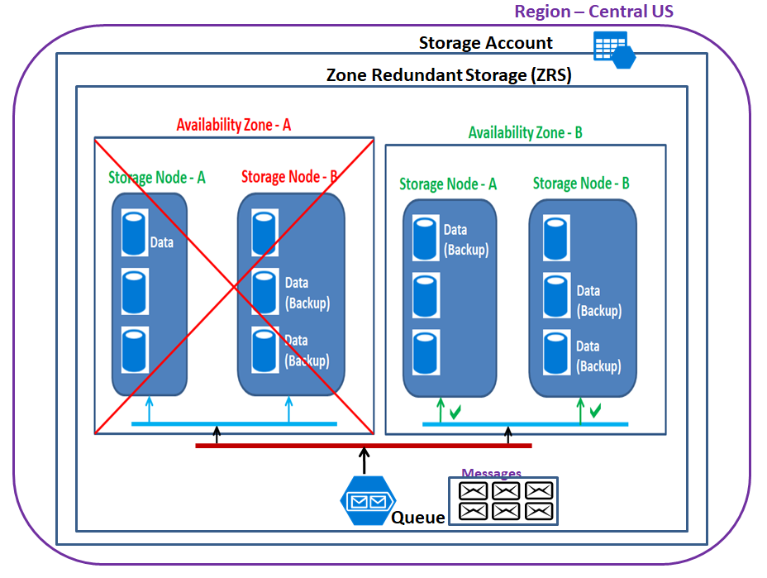

In Azure portal, click **“Resource groups”.**

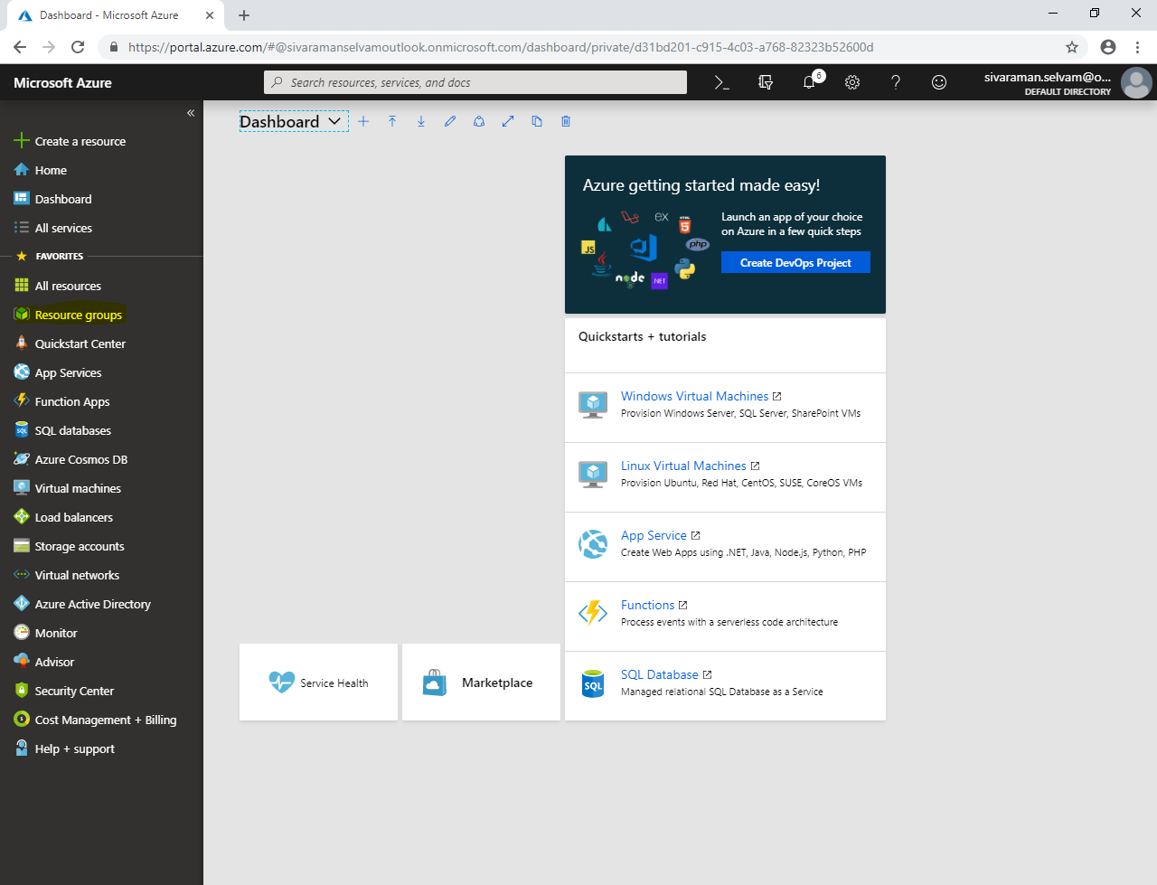

Click **“Add”**.

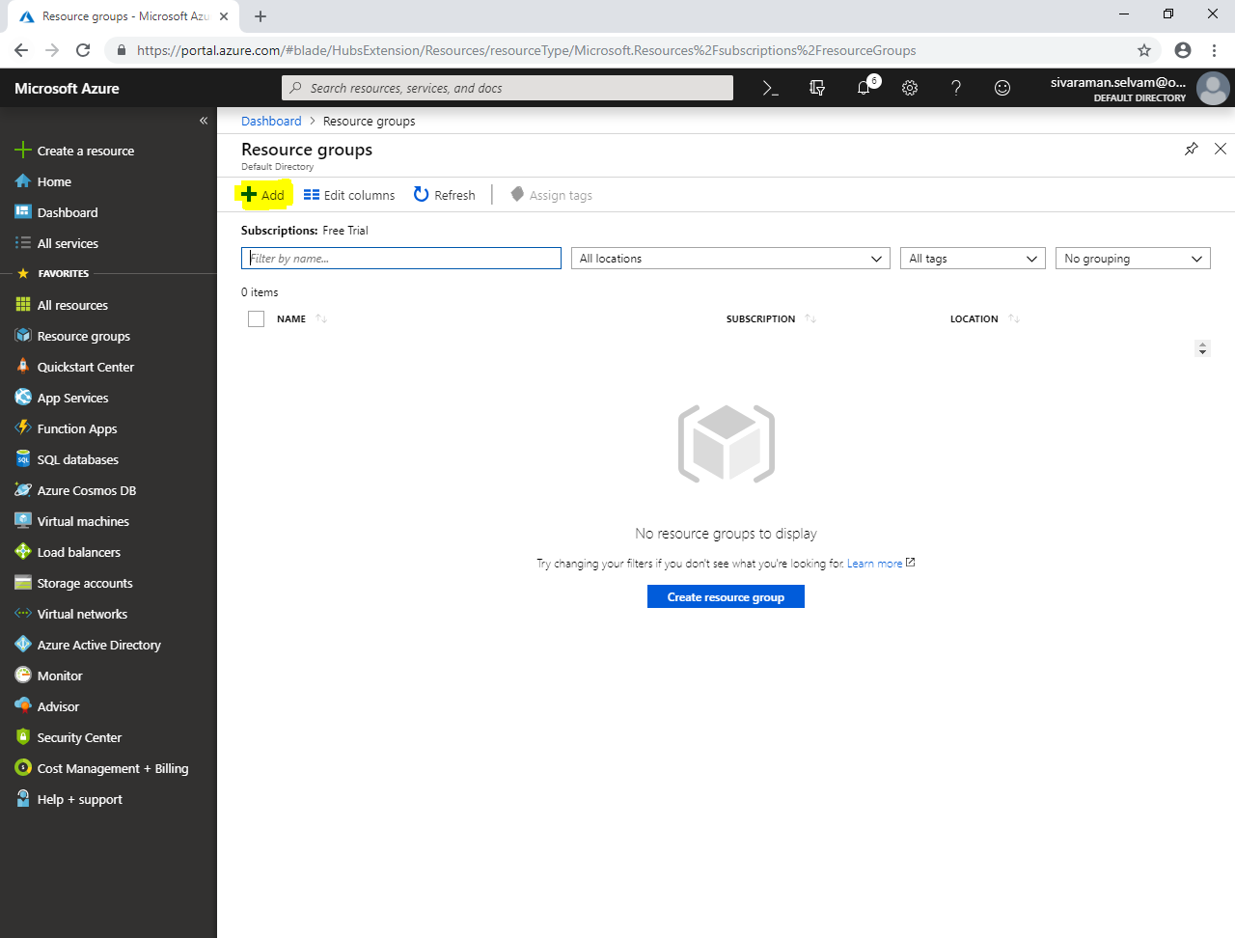

While create **“Resource group”**,

It requires, **“Resource group name”** type name as **“SansboundAzureClass”**.

Select **“Subscription”** as **“Free Trial”**.

Select **“Resource group location”** as **“Central US”**.

Click **“Create”.**

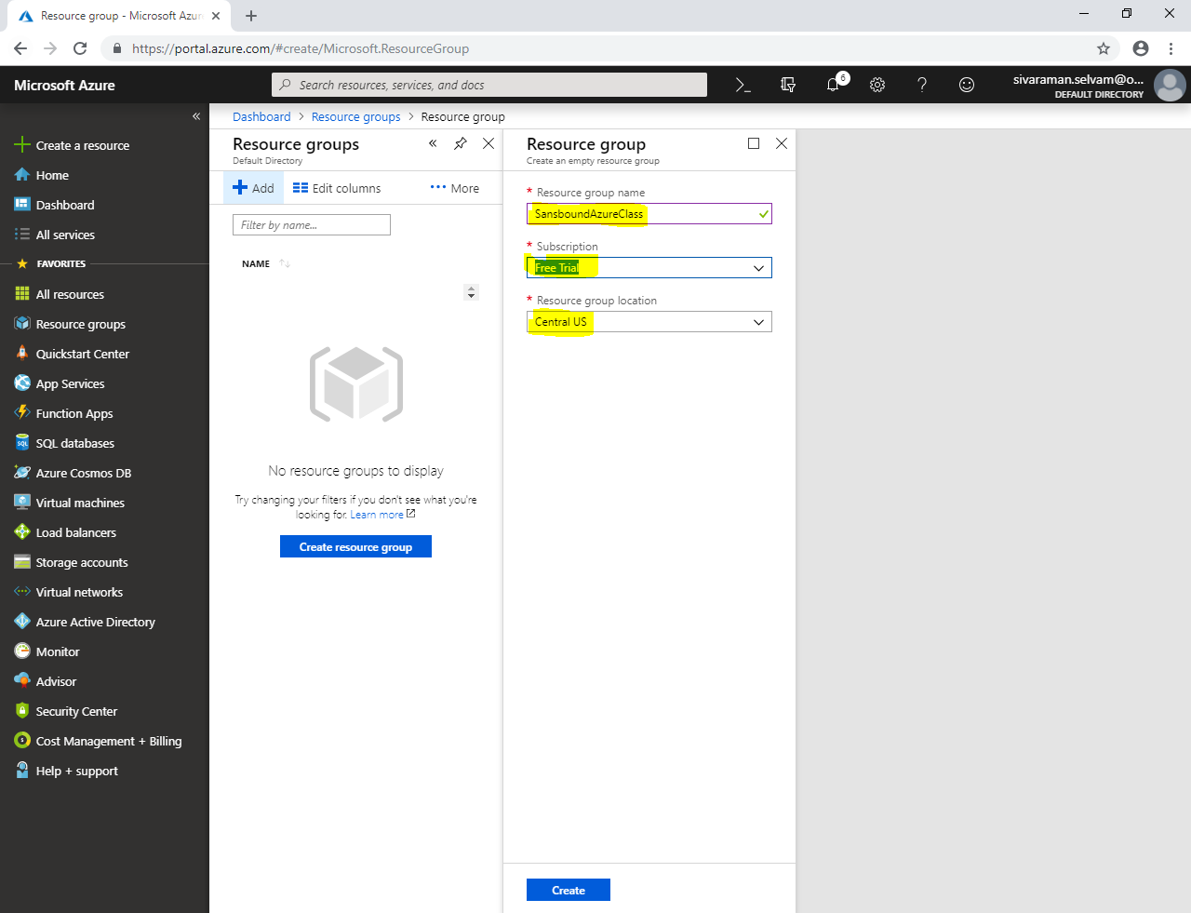

Click **“Storage accounts”** in left side panel.

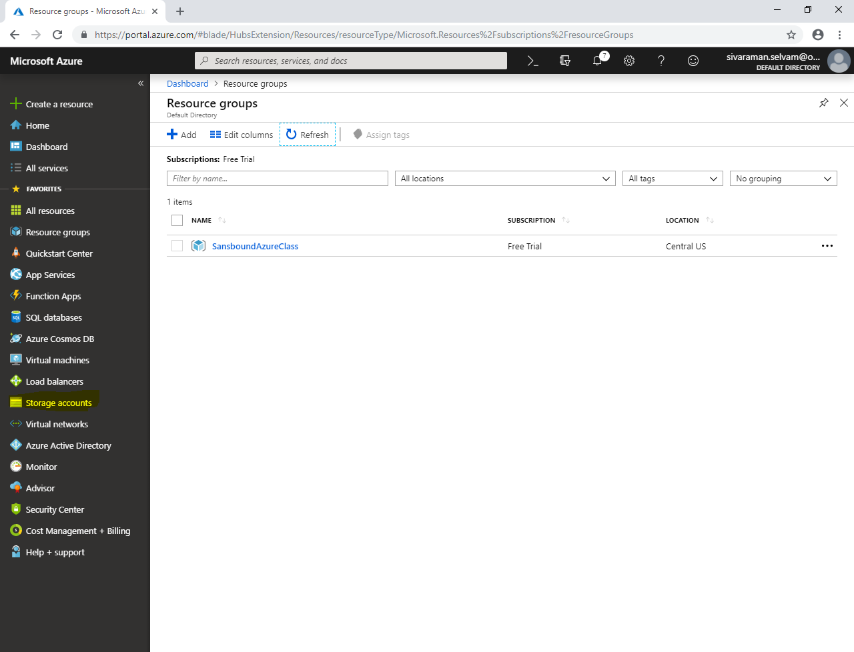

Click **“Add”**.

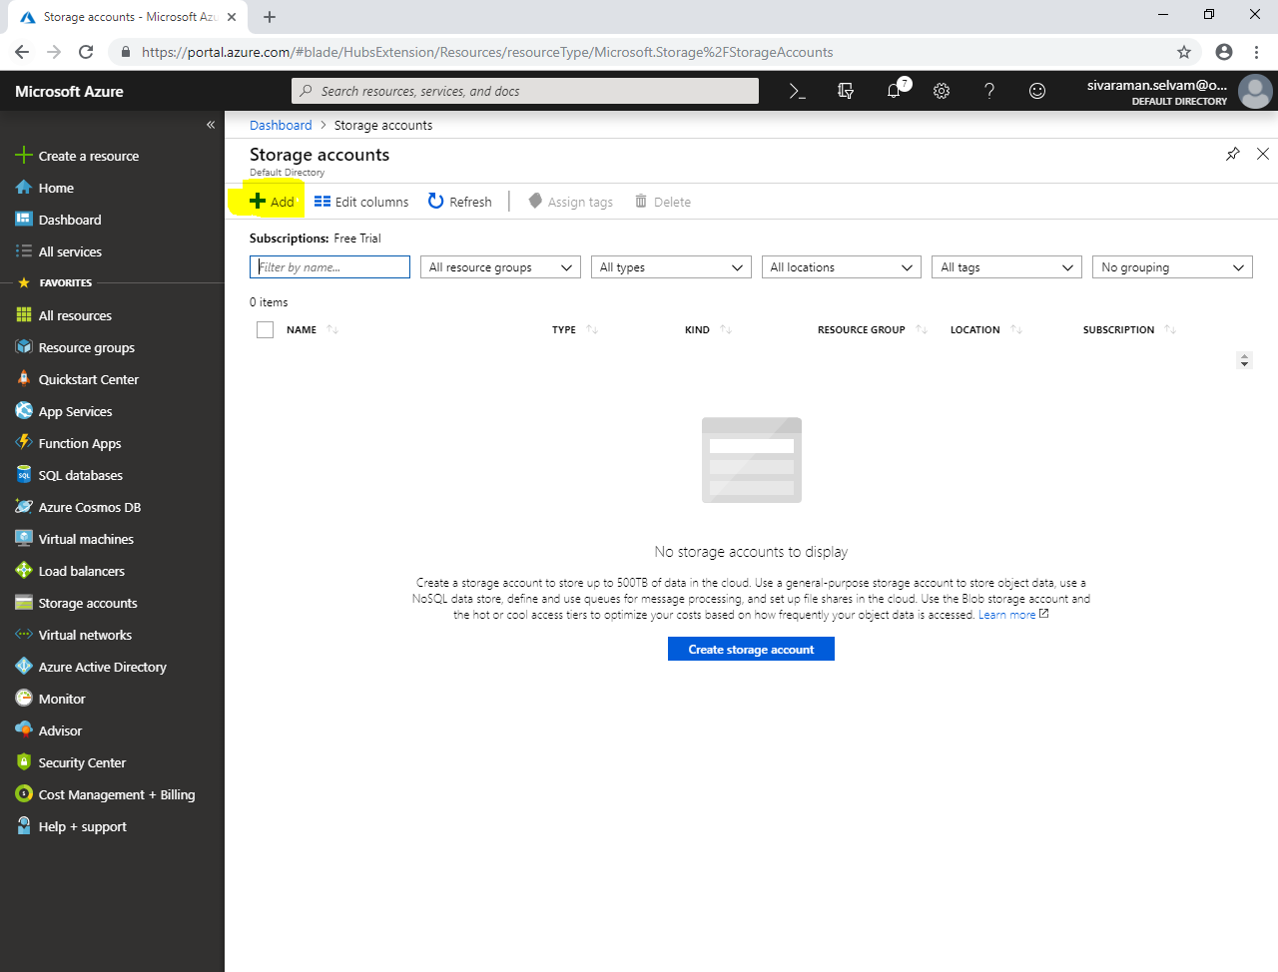

Select **“Subscription”** as **“Free Trial”**.

Select **“Resource group”** as **“SansboundAzureClass”**.

Type **“Storage account name”** as **“sansboundstorge”**.

Select **“Location”** as **“Central US”.**

Select **“Performance”** as **“Standard”**.

Select **“Account kind”** as **“Storage V2”**.

Select **“Replication”** as **“Zone-Redundant Storage (ZRS)”**.

Click **“Access Tier”** as **“Hot”.**

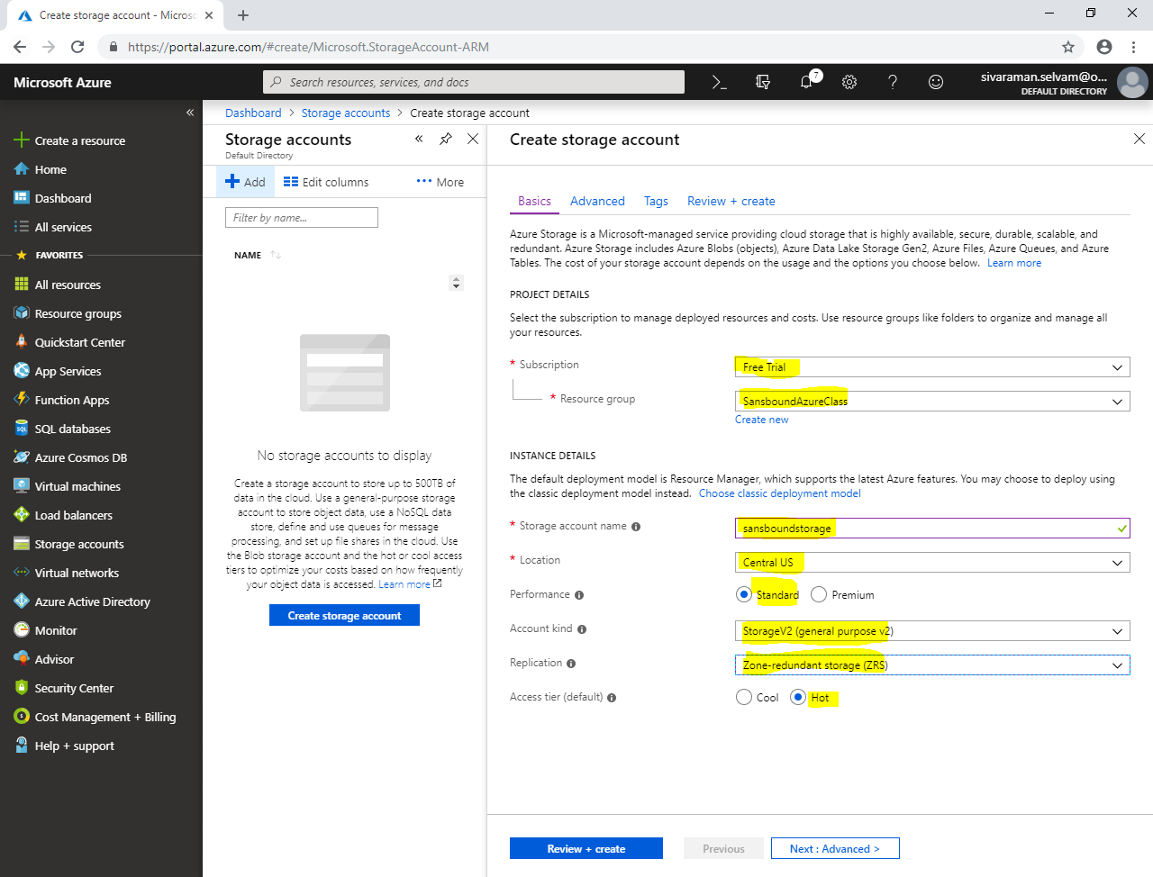

Click **“Next : Advanced”.**

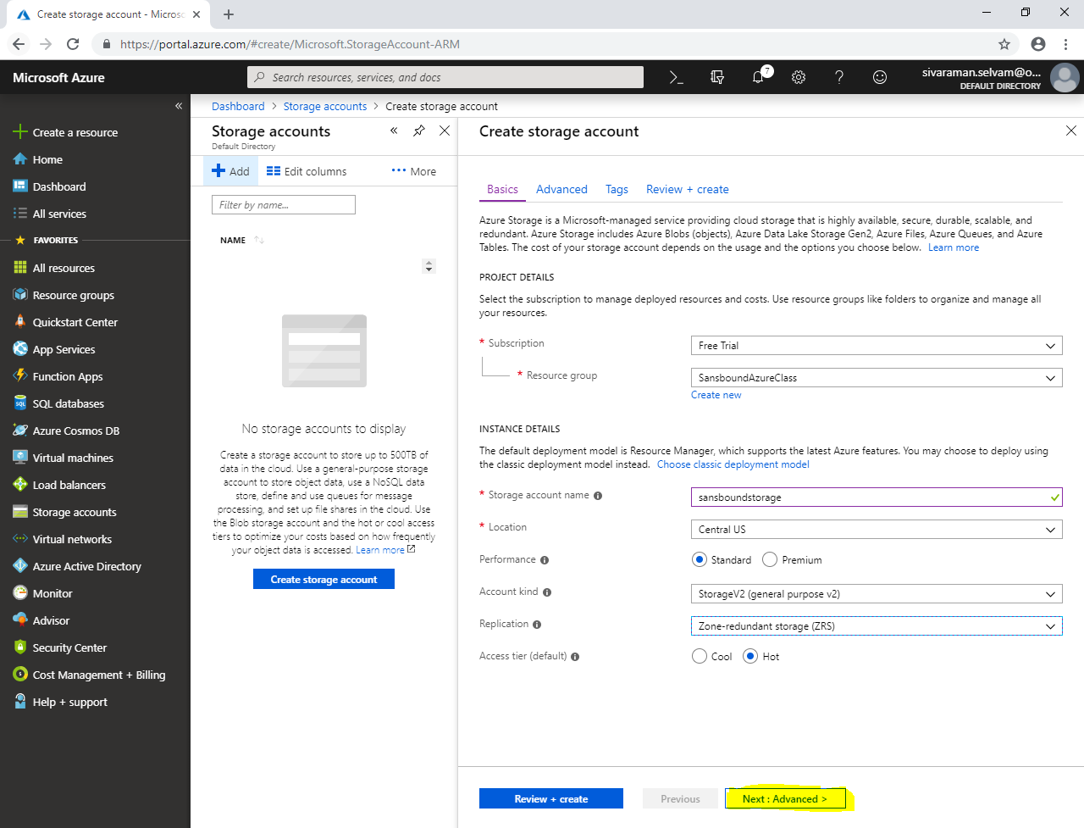

In **“Advanced”.**

Click **“Next : Tags >”.**

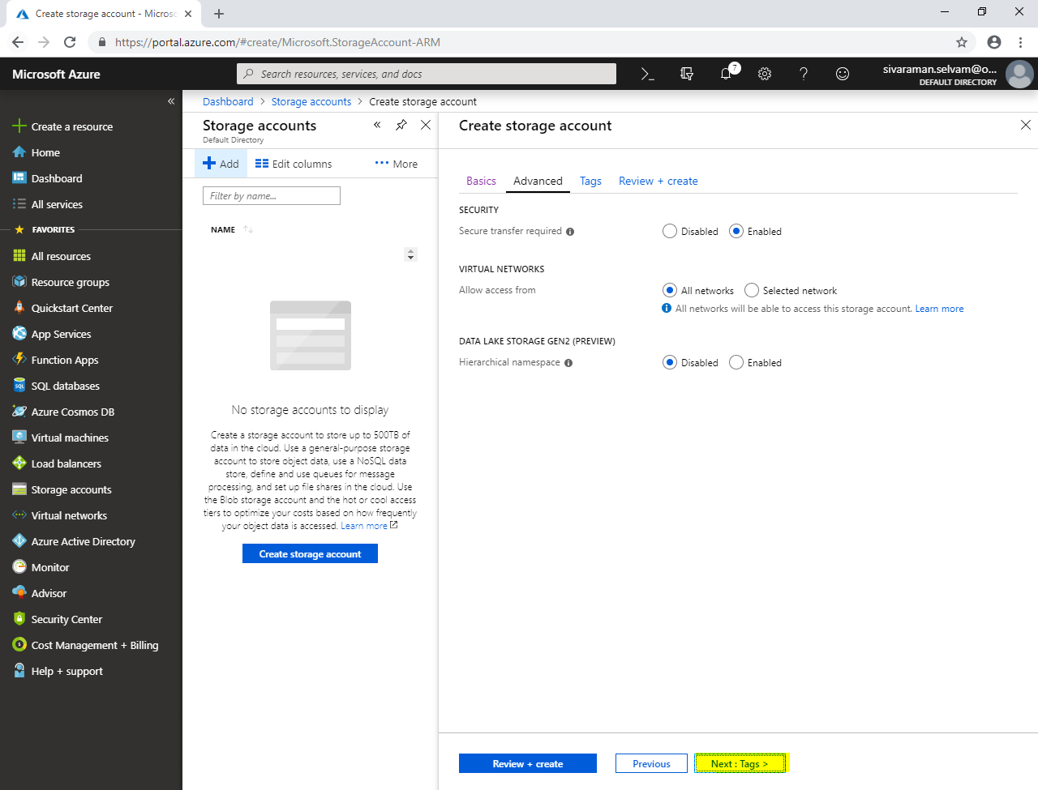

Type **“KEY”** as **“Name”** and **“VALUE”** as **“SansboundStorage”**.

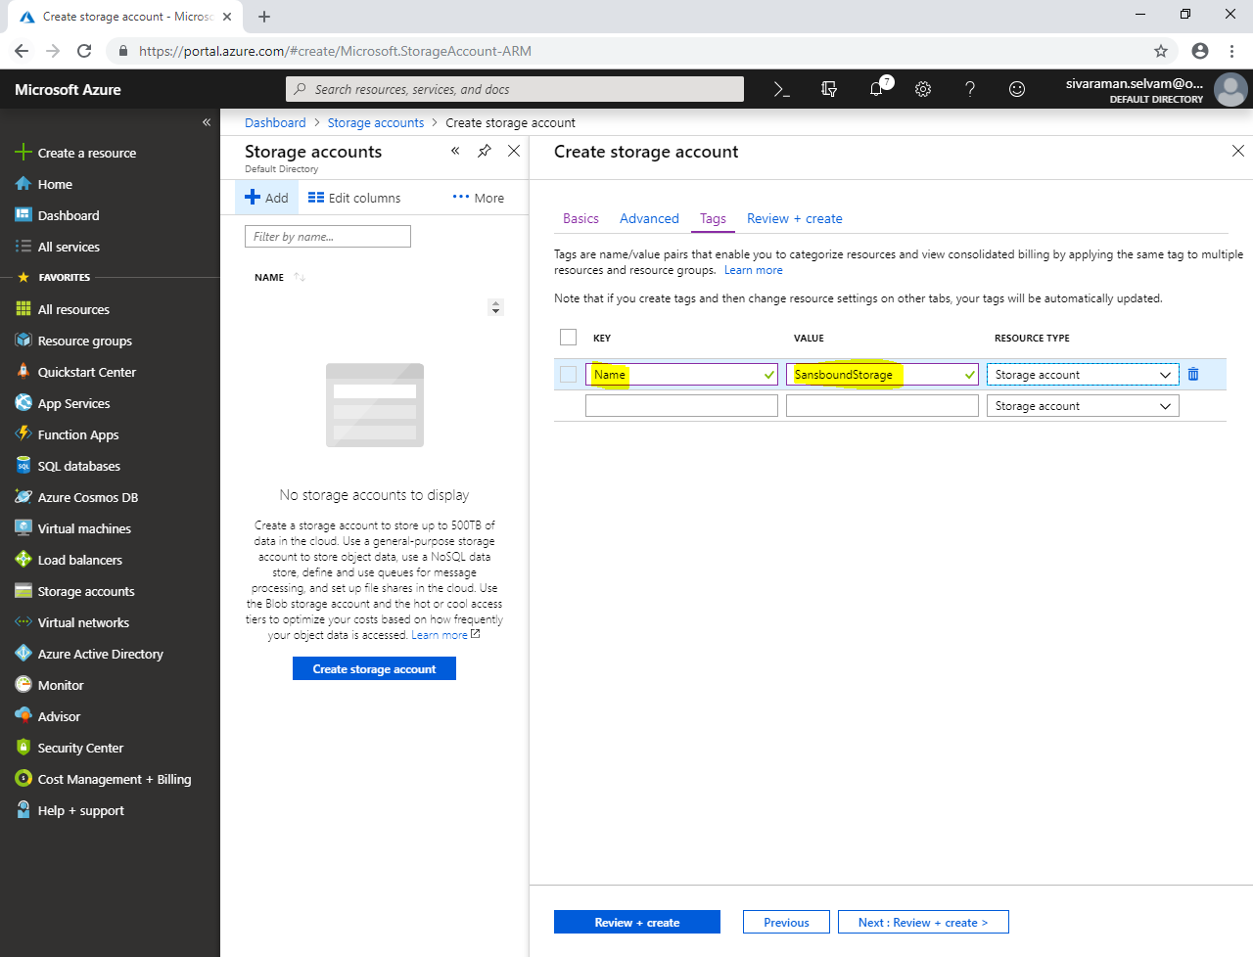

Click **“Next : Review + create”**.

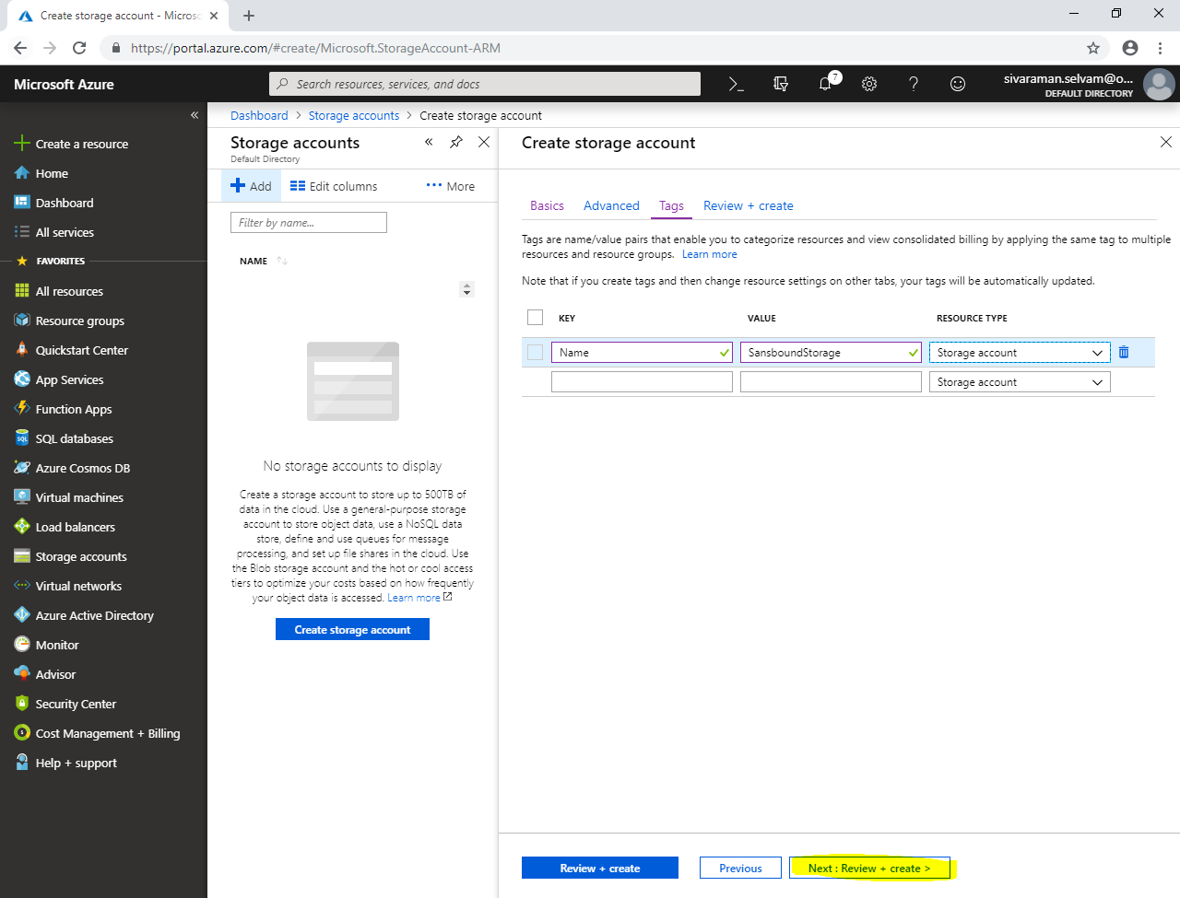

Click **“Create”**.

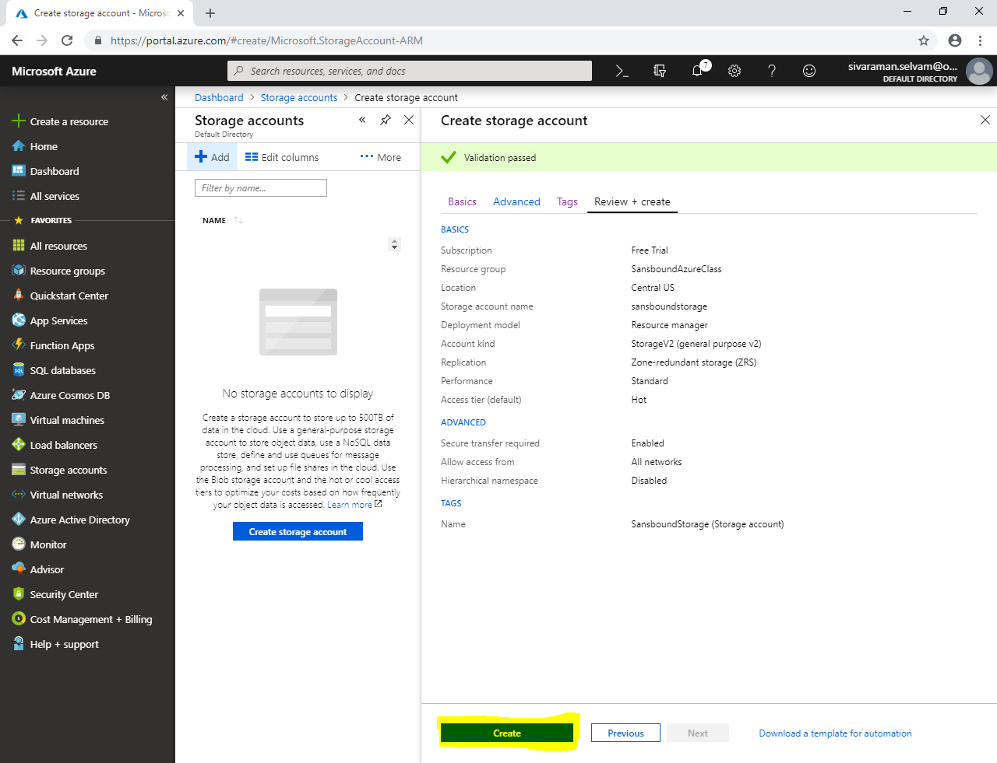

Click **“Go to resource”.**

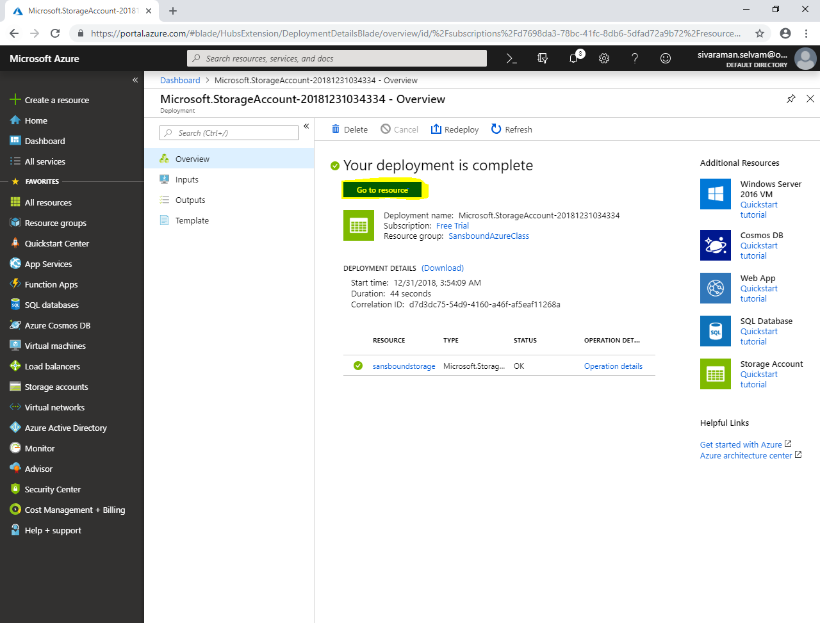

Click **“Queues”**.

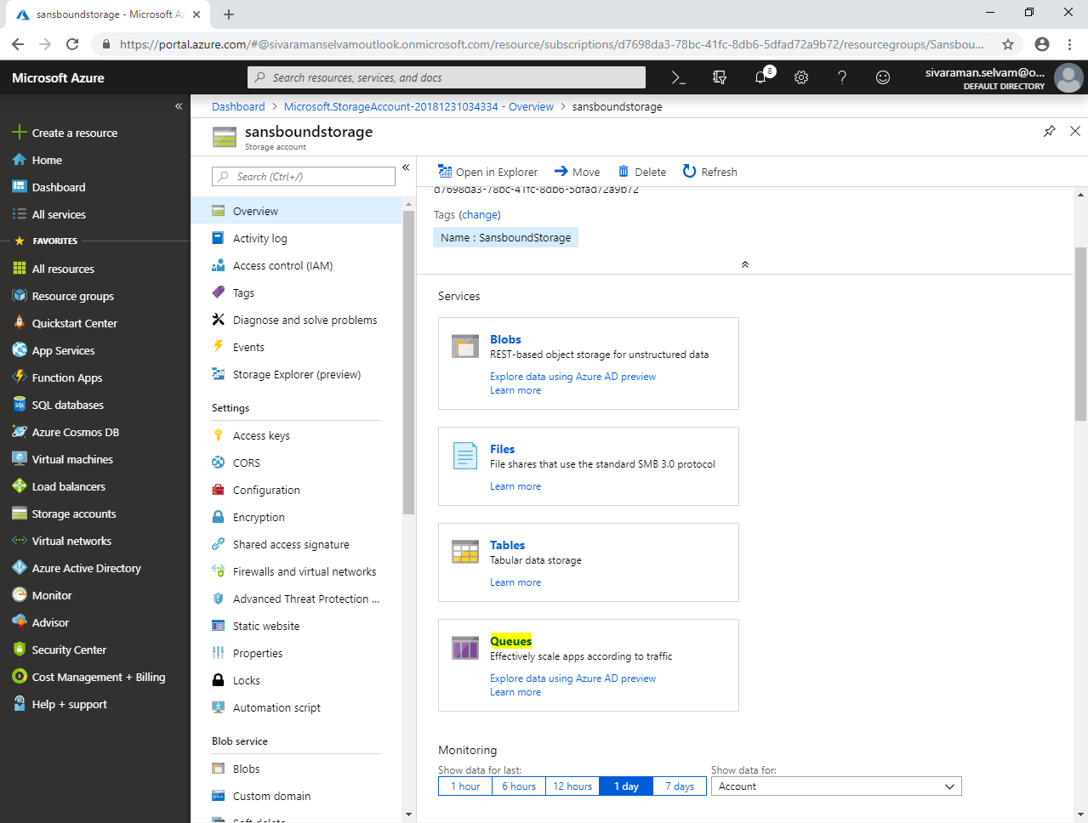

Click **“Queue”.**

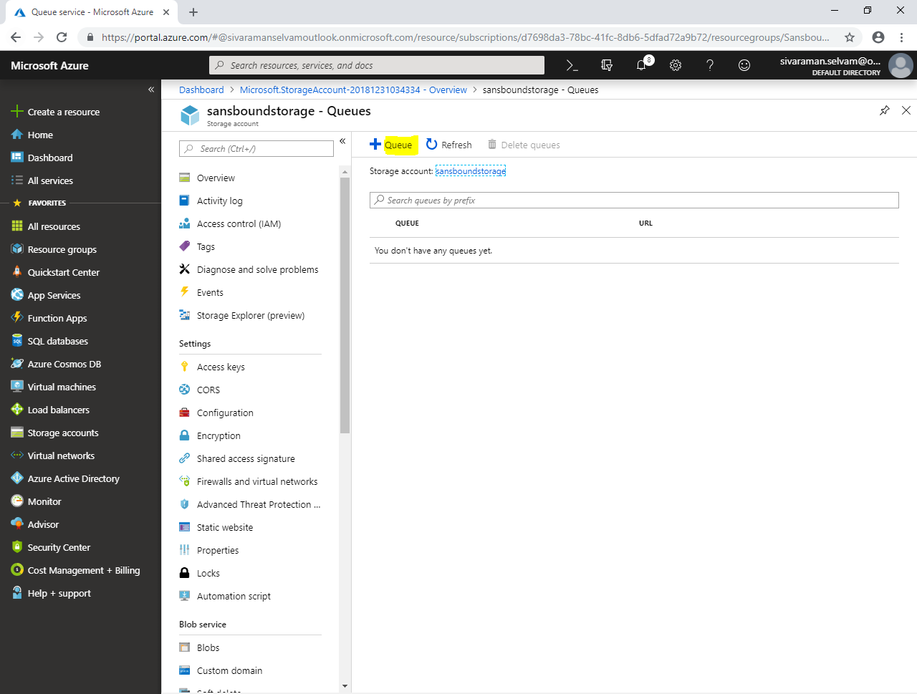

Type **“Queue name”** as **“eventlogs”**.

Click **“Ok”**.

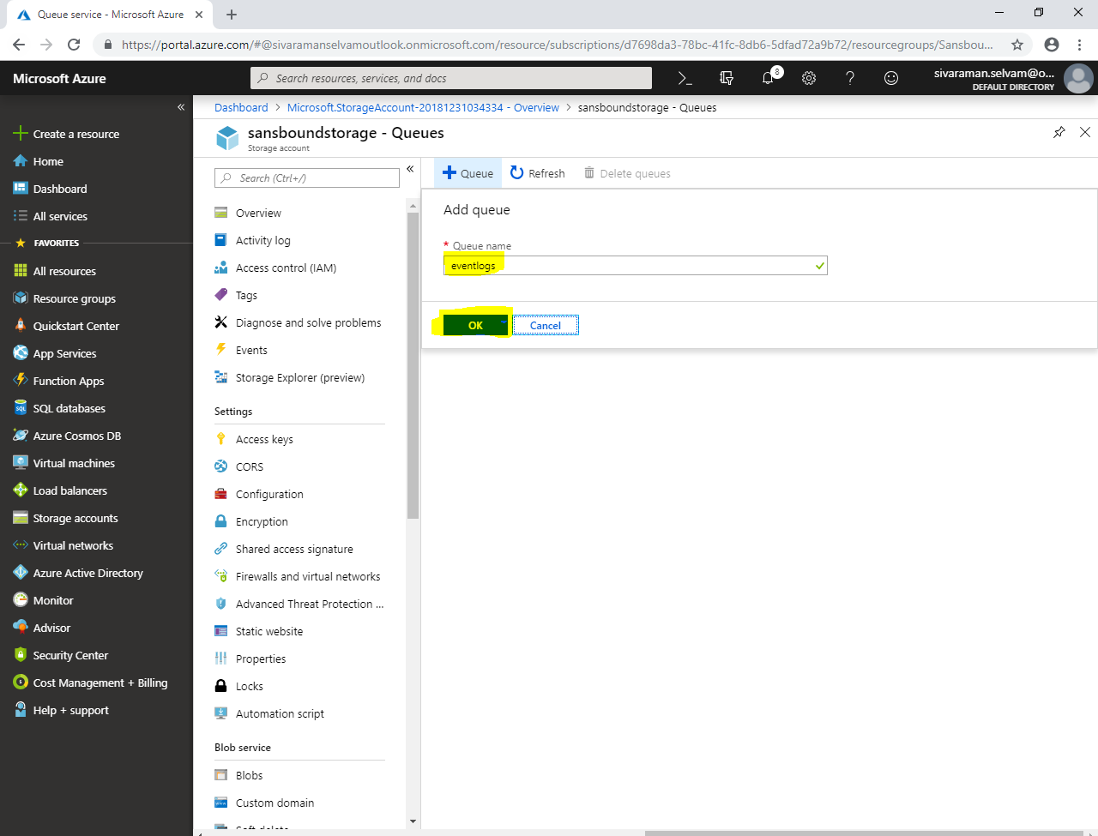

Click **“eventlogs”**.

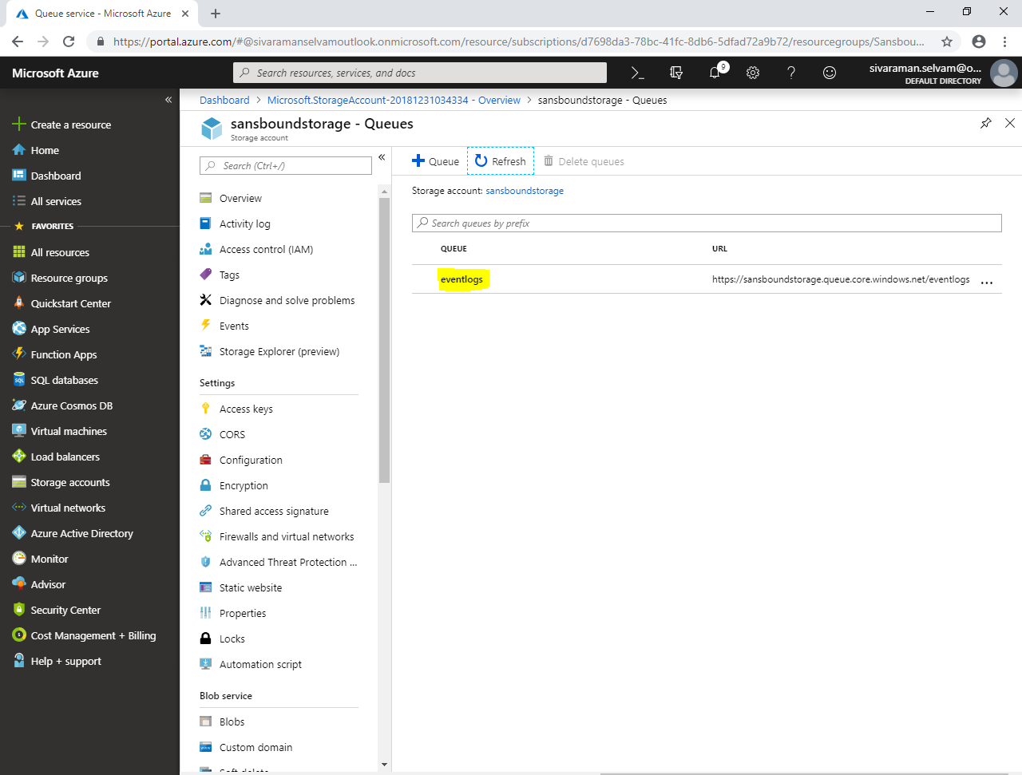

Click **“Add message”.**

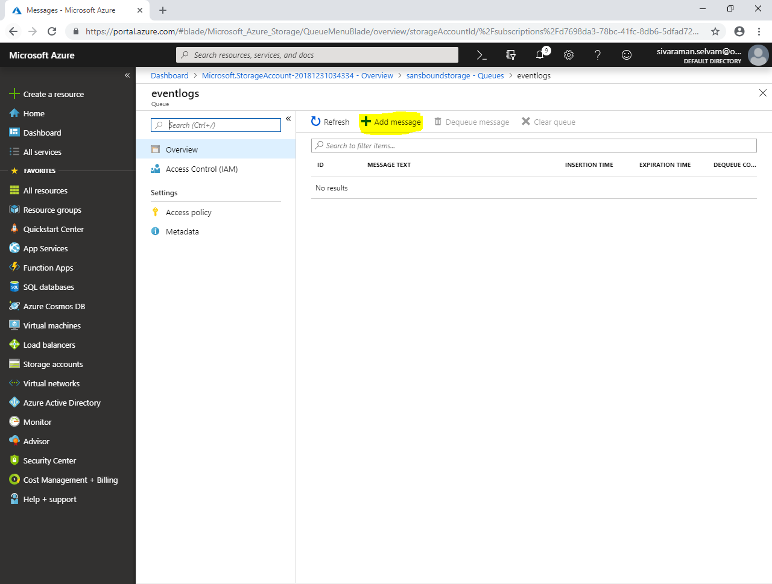

In your local machine / server launch event viewer,

In **“Security”**

Select any **“Audit Success”** event and double click it.

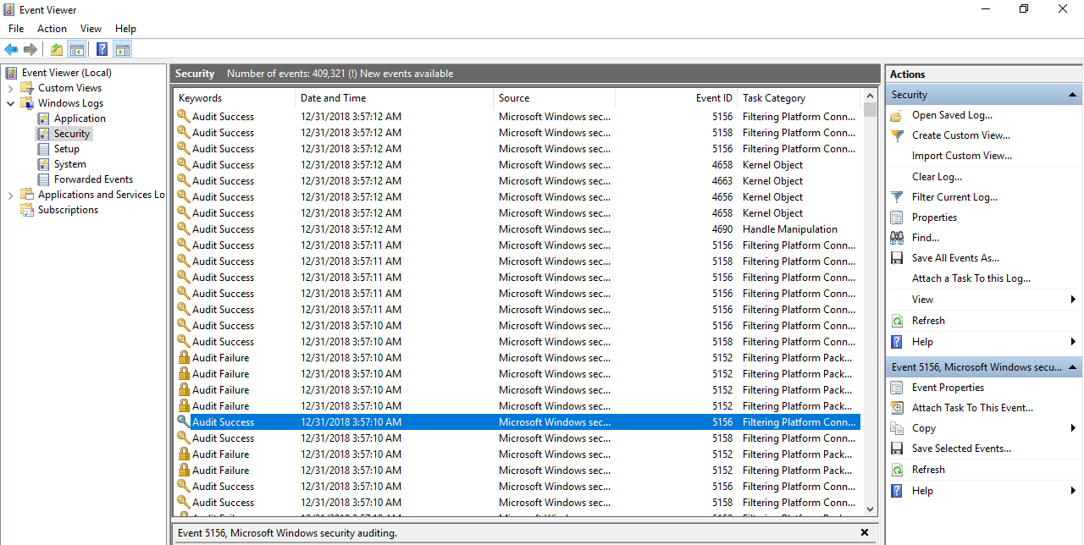

Select entire event details for the event id.

Then, click **“Copy”**.

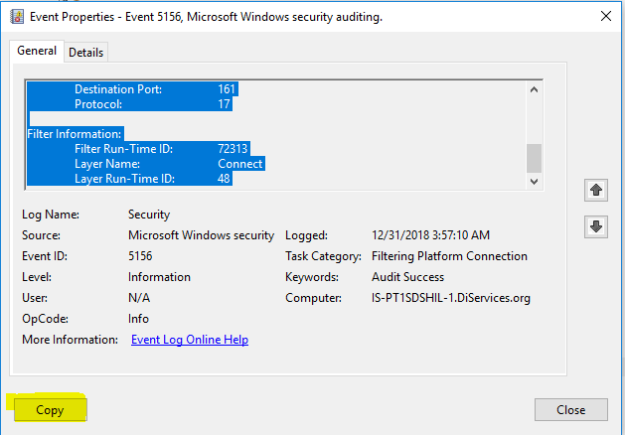

Paste the value in **“Message text”** at **“Add message to queue”.**

Also you can set the expiration period for the message, after that message will be deleted automatically.

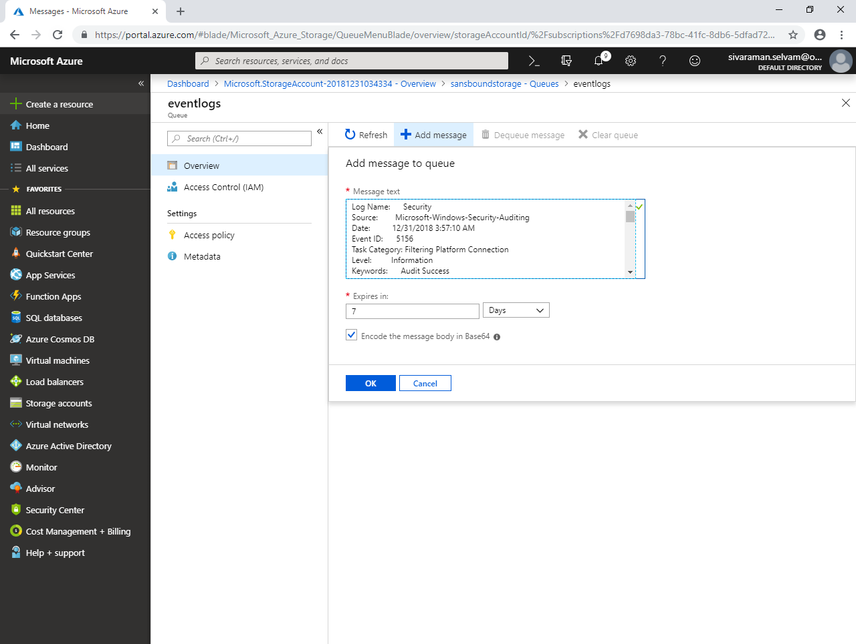

Click **“Id of the message queue”**.

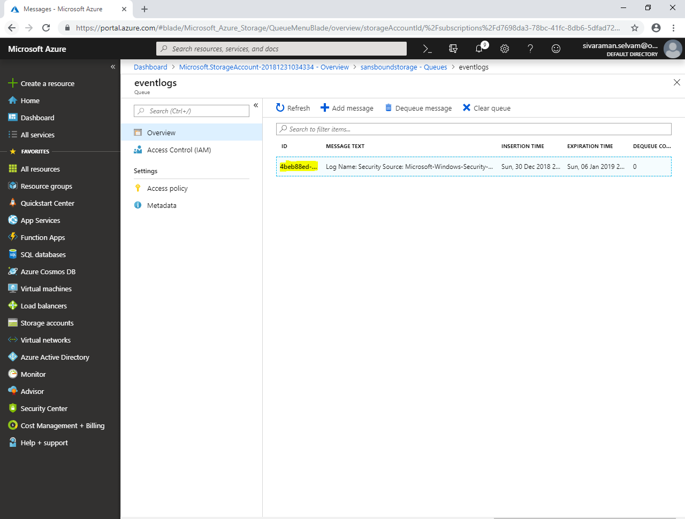

If you have required to delete the specific message, then select that message and then click “Dequeue message” / to click “Clear queue” to delete all messages in the queue.

